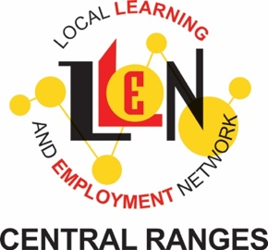 LLEN LOGO 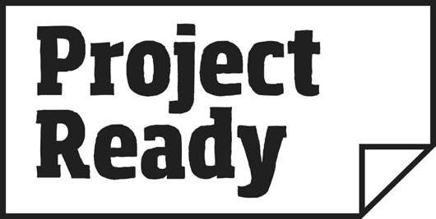

CONFIDENTIALITY AGREEMENT
Project Ready: Certificate II in Active Volunteering

In consideration for the disclosure of materials and resources relating to Project Ready Certificate II in Active Volunteering, developed by Central Ranges Local Learning & Employment Network, I agree, as a duly authorised teacher, school representative, mentor or facilitator of Project Ready Certificate II in Active Volunteering, to keep these materials confidential and not to disclose, transfer, distribute, loan or use such materials for any purpose other than to deliver the program on behalf of <inert LLEN name> Local Learning & Employment Network:

1) Unless written permission is obtained from an authorised representative of Central Ranges Local Learning & Employment Network.

I understand that the transfer of any program materials or resources to me (the teacher, mentor, school representative or facilitator) shall not be construed as granting a licence or any right of ownership in relation to the resources, materials or the intellectual property.

I further understand that this agreement constitutes the entire understanding between the parties relating to the safeguarding of information transferred, and supersedes all prior related discussions and understandings.

DATE OF AGREEMENT _______________________________________________

FACILITATOR/TEACHER/MENTOR NAME: _______________________________

___________________________________________________________________

SIGNATURE ________________________________________________________

LLEN REPRESENTATIVE: _____________________________________________

SIGNATURE ________________________________________________________

WITNESS NAME_____________________________________________________

WITNESS SIGNATURE________________________________________________

